|  |  |
| --- | --- |
| *Pacific Gas and Electric Company* | |
| Release 9.7.5A Installation Guide | |
|  |  |
|  |  |
| Project | ED AM/GIS |
|  |  |
| Prepared by | Subhankar Baidya |
| Date | 9/21/2015 |
| Version | 1.0 |
| Version Type | Draft |

|  |  |  |  |
| --- | --- | --- | --- |
| Revision History | | | |
| Document # | Date | Author | Summary of Changes |
| 1.0 | 9/11/2015 | Subhankar Baidya | Initial Document Creation |
|  |  |  |  |

# Introduction

## Purpose

This document is intended to detail the implementation and configuration steps required to implement Release 9.7.5 Installation Guide. This document describes the various configuration aspects required to complete any manual or automatic patch associated with this release. Each section in this document contains the steps required to patch the system in production.

## Terms Used

|  |  |
| --- | --- |
| OOTB | Out of the box. Unmodified from the commercial version. |
| TFS | Team Foundation Server |

## External Documents

Referenced are any external configuration documents or exports. These are documents that contain more detailed information about configuring a system or documents that can be loaded into an application to perform the configuration detailed in this document.

1. Supporting documentation folder
   1. **TFS documentation location:**

$/EDAMGIS/Source_Development_10_2_1/Documentation/Data Model/Release Documentation/EDER/9.7.5

## List of Fixes

Below is the list of change requests detailing all fixes for the data model for this release:

|  |  |
| --- | --- |
| **Item Number** | **Title** |
| [24374](http://edappgistfsprd1:8080/tfs/ElectricDistCollection/EDAMGIS/_workitems/edit/24374) | Master TFS DM 9.7.5A |
| [24367](http://edappgistfsprd1:8080/tfs/ElectricDistCollection/EDAMGIS/_workitems/edit/24367) | Apply PGE_CONDUCTORCOUNT model name to DCConductorInfo |
| [23273](http://edappgistfsprd1:8080/tfs/ElectricDistCollection/EDAMGIS/_workitems/edit/23273) | PAR 112393: Missing codes/values for Dyn Protect Device Type Interrupter domain |
| [24371](http://edappgistfsprd1:8080/tfs/ElectricDistCollection/EDAMGIS/_workitems/edit/24371) | PAR 112393: Sort Dyn Protect Device Type Interrupter domain values |
| [24460](http://edappgistfsprd1:8080/tfs/ElectricDistCollection/EDAMGIS/_workitems/edit/24460) | Configure ValidateMultiFeedFeatureNonSecondary on EDGIS.OpenPoint subtype Open Point and subtype Pseudo Open Point |

Contents

1 Introduction 3

1.1 Purpose 3

1.2 Terms Used 3

1.3 External Documents 3

1.4 List of Fixes 4

2 EDGIS 6

2.1 24367: Apply PGE_CONDUCTORCOUNT model name to DCConductorInfo 6

2.2 23273: PAR 112393: Missing codes/values for Dyn Protect Device Type Interrupter domain 7

2.3 24371: PAR 112393: Sort Dyn Protect Device Type Interrupter domain values 8

2.4 24460: Configure ValidateMultiFeedFeatureNonSecondary on EDGIS.OpenPoint subtype Open Point and subtype Pseudo Open Point 10

2.5 Update Data Model Version Table 12

3 Known Issues 13

# EDGIS

## 24367: Apply PGE_CONDUCTORCOUNT model name to DCConductorInfo

1. Right-click on the DCConductorInfo table in the root dataset and select ArcFM Properties Manager
2. Select the Field Model Names tab
3. Select the CONDUCTORCOUNT field
4. Apply the PGE_CONDUCTORCOUNT field model name from the PGE ED Field Model Name domain

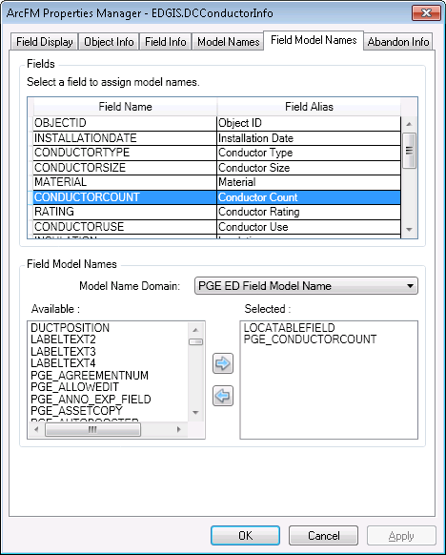

1. Click OK

## 23273: PAR 112393: Missing codes/values for Dyn Protect Device Type Interrupter domain

Add code/values to the domain: **Dyn Protect Device Type Interrupter**

*\*\*\* If domain values are already added, skip the CR.*

**Code** **Description**

ISSI ISSI

GW G&W

EM Elastimold

1. Open ArcCatalog. Get exclusive access of EDGIS user.
2. Right Click on the root node. Select “Properties”.
3. Add code/values to the domain: Dyn Protect Device Type Interrupter.

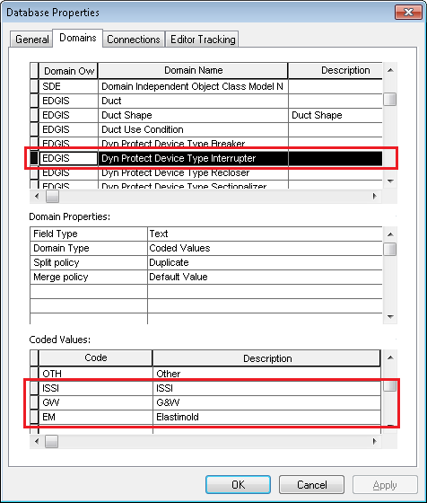

1. Click Apply. Click OK.

## 24371: PAR 112393: Sort Dyn Protect Device Type Interrupter domain values

1. In ArcCatalog right click anywhere on the main toolbar and select Customize…
2. Select the commands tab
3. From the 'Developer Samples' commands category, add the 'Sort a domain' command to an existing toolbar or the context menu for a geodatabase. Note: If the category and/or Sort a domain command are not available, use ‘Add from File’ and load the DomainSort.dll from the ‘Sort_a_domain\Visual_Basic’ directory of the release folder
4. Use ArcCatalog to browse to the EDER database to sort a domain from.
5. Click on the command to bring up the dialog, and make choose below parameters for the sort.

Available Domains: - Dyn Protect Device Type Interrupter

Sort Type: - Ascending

Sort Item: - Description

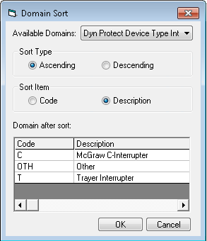

1. Click on Ok.
2. Click on the root node of the database. Select “Properties…” to open the domain window.
3. Navigate to Dyn Protect Device Type Interrupter domain.
4. Delete OTH code. Click Apply.



1. Add OTH at the end of the Coded Values list (after T)

Code: **OTH** Description: **Other**

1. Click Apply. Click OK.

## 24460: Configure ValidateMultiFeedFeatureNonSecondary on EDGIS.OpenPoint subtype Open Point and subtype Pseudo Open Point

These steps will create a model name, assign it to Open Pont field SecondaryIDC and then assign the new Validation rule to only two of the subtypes for open point.

1. Open ArcCatalog
2. Create a connection as EDGIS user to the database to be modified.
3. Connect to the database
4. Right click on the database connection and choose properties
5. Select the "Domains" tab
6. Select the Domain in the list of "PGE ED Field Model Name"
7. Add the code and description of "PGE_SECONDARYIDC"
8. Click ok to save the change
9. Select the Feature Class EDGIS.OpenPoint under the "EDGIS.ElectricDataset" feature dataset
10. Right click the feature class and choose the "ArcFM Properties" option
11. Select the "Field Model Names" tab
12. In the top dialog choose the field SecondaryIDC
13. In the bottom portion of the dialog set the Model Name Domain to the "PGE ED Field Model Names" then find ad assign the model name of "PGE_SECONDARYIDC" created in step #7
14. Save the change by hitting OK.
15. **You must completely exit ArcCatalog and Re-Open it again for this next step**. Please close ArcCatalog and re-open it and connect to the database, then select open point feature class again. Same steps as #9
16. Right Click the Feature Class again and open the ArcFM Properties one more time, same as step #10
17. Select the "Object Info" tab
18. Choose the Subtype of OpenPoint from the drop down for Subtype.
19. Uncheck the Rule, "PGE Validate Multi-feed Feature"
20. Select the Rule, "PGE Validate Multi-feeder Non-Secondary Feature".
21. Apply
22. Choose the Subtype of "Pseudo Open Point" from the drop down for Subtype.
23. Uncheck the Rule, "PGE Validate Multi-feed Feature"
24. Select the Rule, "PGE Validate Multi-feeder Non-Secondary Feature".
25. Apply
26. Click OK to close the dialog and save all settings.

## Update Data Model Version Table

**Database Configuration:**

1. Open SQL Plus.
2. Log in using the same server and user as was used in section 2.1.  
     
   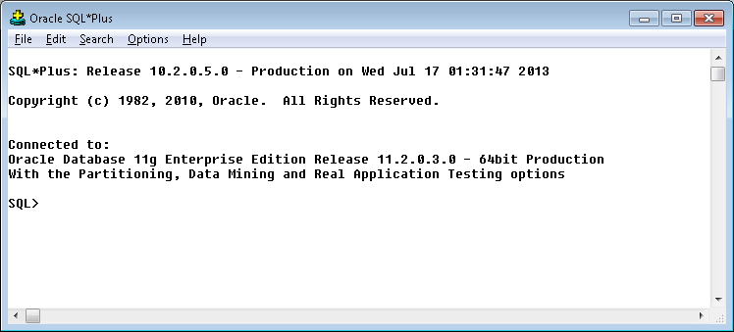
3. Run the SQL below:

update pgedatamodelversion set currentidc='N' where currentidc='Y';

insert into pgedatamodelversion (OBJECTID, CURRENTIDC, DATEAPPLIED, APPLIEDBYPERSONNAME, MODELVERSION) values (**SDE.VERSION_USER_DDL.NEXT_ROW_ID('EDGIS',(select registration_id from sde.table_registry where table_name='PGEDATAMODELVERSION'))**,'Y',sysdate,'**Philip Penn**','**9.7.5A** GOLD');

commit;

# Known Issues

<Please List any other issues encountered here while following the document>